Complete processing process of aluminum extrusion die
- Saw machine sawing round steel process
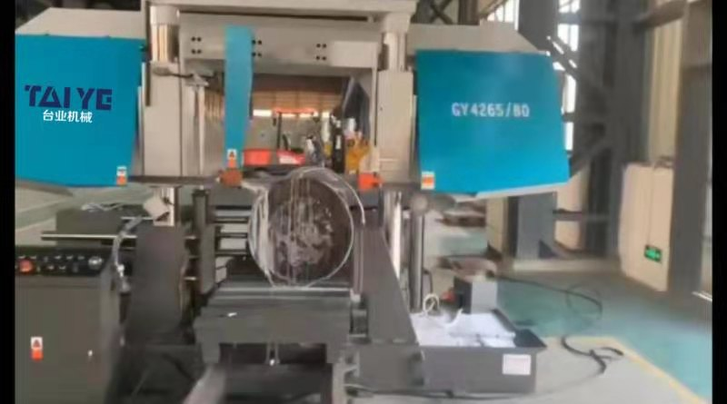

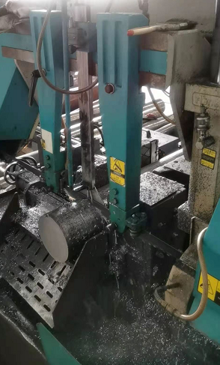
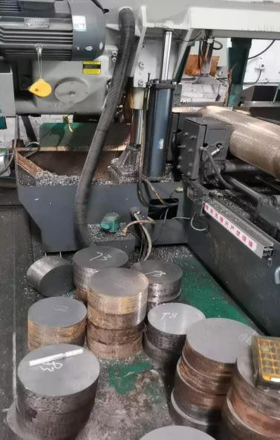
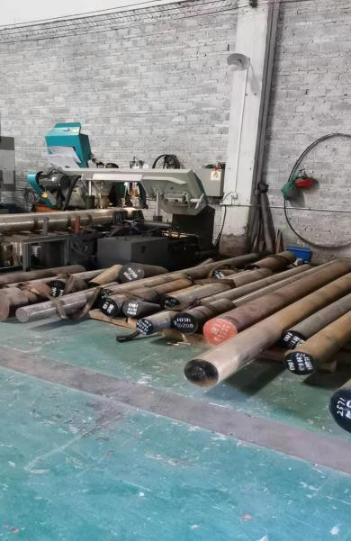

Taiye's CNC band sawing machine is an efficient sawing equipment which is beautiful appearance design, good structural design stability, and strong rigidity. It is specially used for various metal materials, square materials, round materials, etc., and can also be adapted to the sawing processing of various ferrous and non-ferrous metal materials.
The band saw using advanced PLC control, it has the characteristics of reasonable structure, stable performance, simple and reliable operation. It is suitable for cutting all kinds of ferrous metals and non-ferrous metals. It is an ideal product with narrow incision, high efficiency, and energy saving.

Features of the machine tool: 1. This equipment has two operating modes, manual and automatic, hydraulic feed system, step-less speed regulation system, hydraulic clamping system, and belt break protection device.
2. The hydraulically driven movable platform can move the work-piece back and forth quickly and correctly to complete the positioning. Move the rack to support the material, and the positioning is more accurate.
3. The lowering speed of sawing is controlled by a speed regulating valve, which effectively prevents abnormal operation of the saw band and achieves the best working effect.

2.CNC lathe processing die billet process
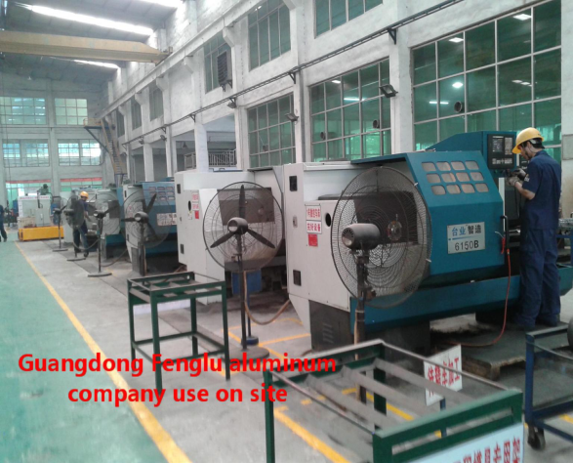
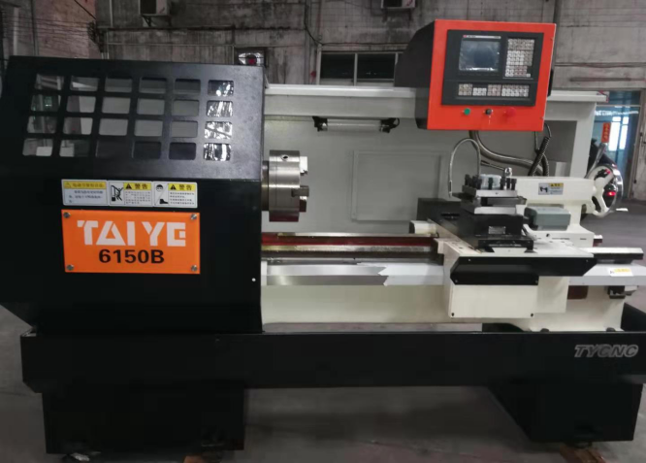

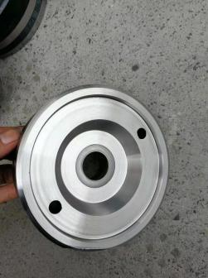
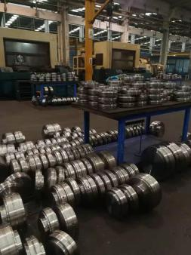
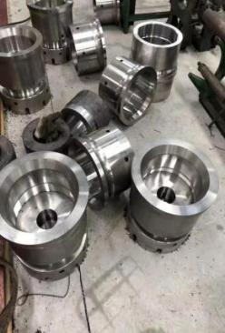
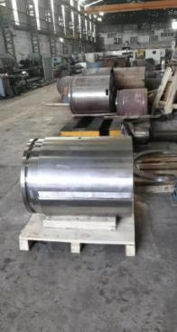
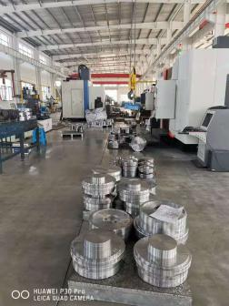

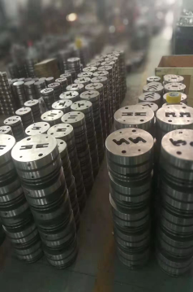
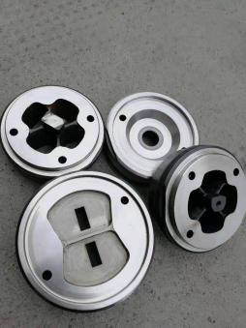
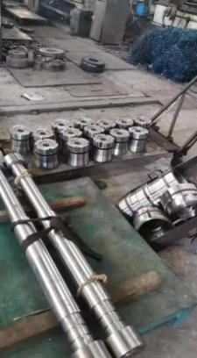
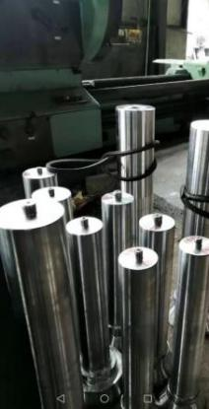
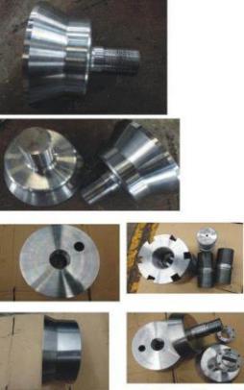

Taiye’s best product - fool-like CNC lathe, no programming require, easy to operate, simply inputting numbers to production, one person can operate 2-3 machine tools at the same time. It has good efficiency, good quality and high precision.
This CNC lathe is widely used in die production industry. In China, mostly die factory uses our equipment, and our lathe are sold well to Southeast Asia, South America, Africa and other regions, and are highly praised by users

3.Pneumatic marking machine
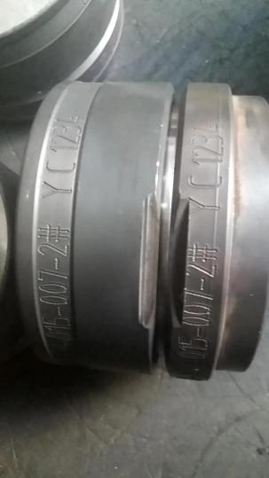
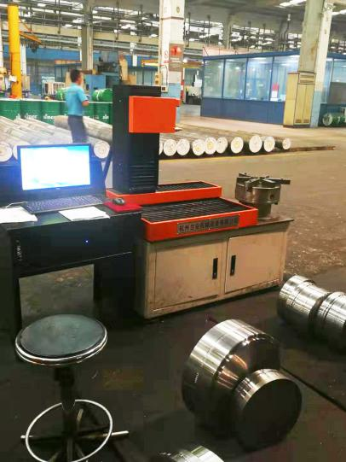
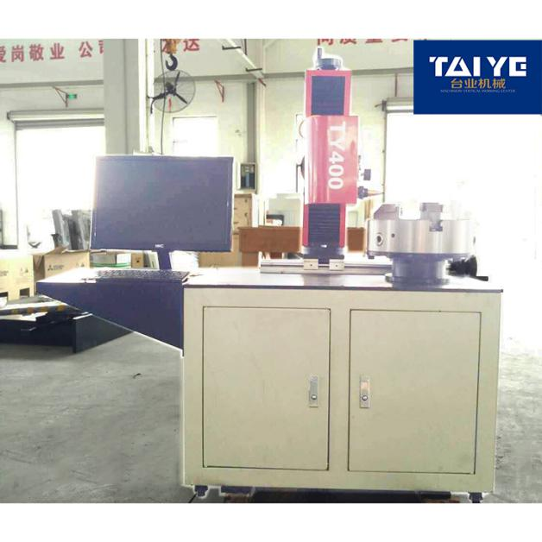

Taiye pneumatic marking machine is computer control, the printing needle makes high-frequency impact motion under the action of compressed air, thereby printing a mark with a certain depth on the workpiece.

4.CNC millingmachining center
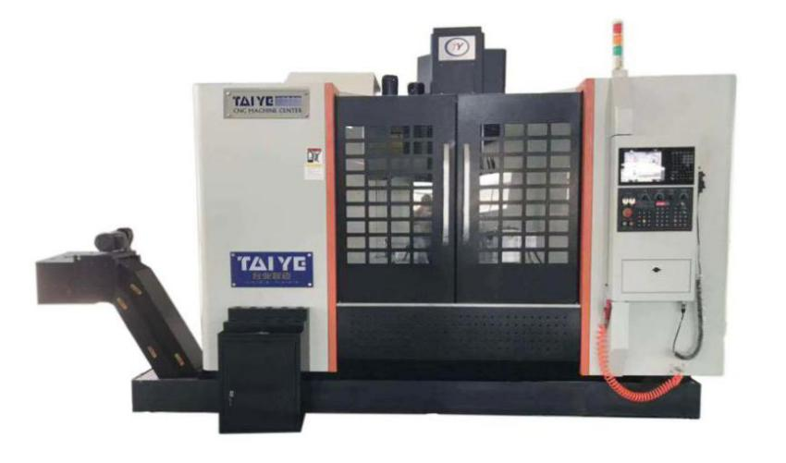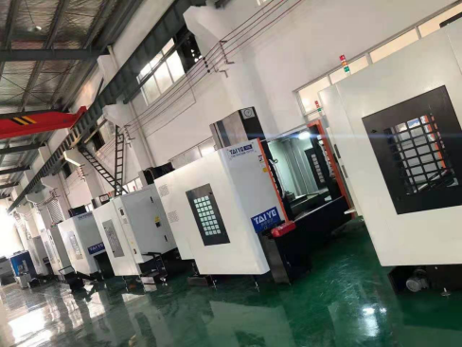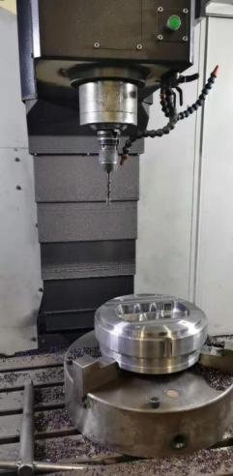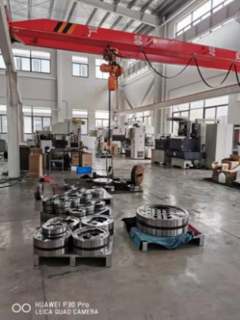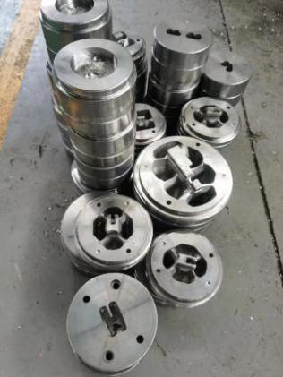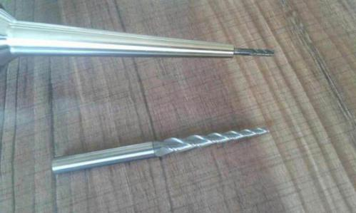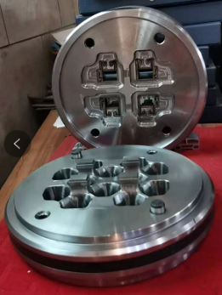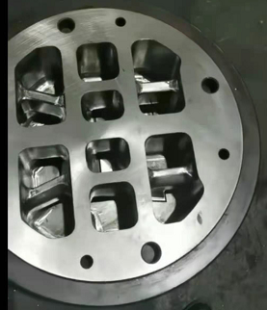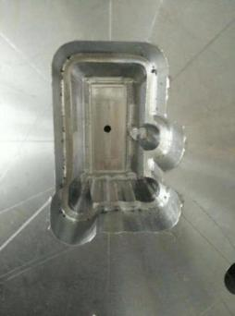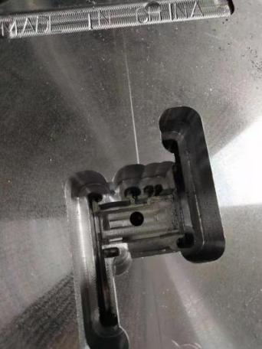
The die can be milled, bored, drilled, expanded, reamed, tapped, and other multi-process processing in milling machine center after one clamping.
Use the non-programming intelligent software which is developed and created by Taiye company, you do not need to program, you do not need professional skills, our equipment Easy to operate with Fully graphical interface, and the products produced by our machines are of accurate size and beautiful appearance, at the same time , it will greatly improve the production efficiency, you will no longer worry about the quality, efficiency and the workers.
Taiye machinery, intelligent manufacturing for you.
5.Radial drilling machine
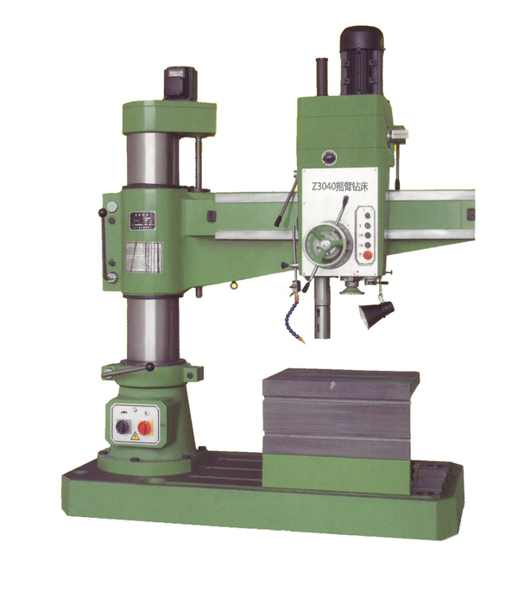
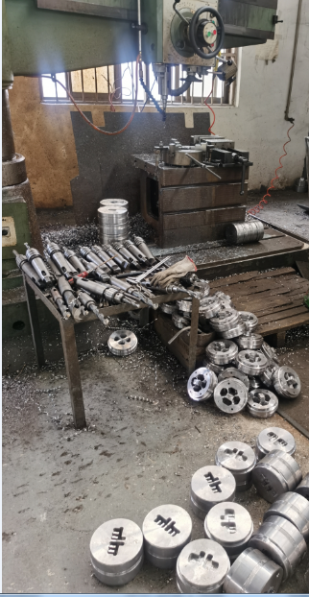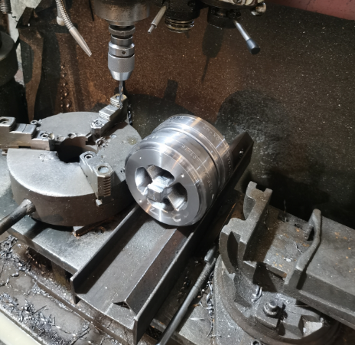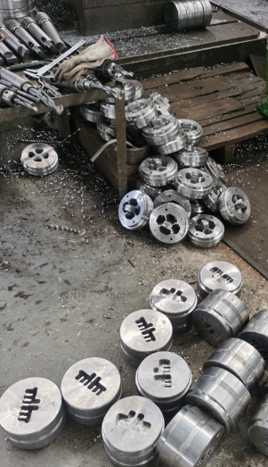
1.Radial drilling machine is suitable for drilling, reaming, reaming, plane and tapping of medium and large parts. Boring can be carried out under the condition of technological equipment.
2. Continuous processing by specialized equipment to ensure excellent basic components.
3. The hydraulic pre-selection speed change mechanism is adopted, which can save auxiliary time.
4. The movement of main shaft forward and reverse, parking (brake), speed change, neutral gear, etc., is controlled by a handle, making the operation more convenient and quick.
5. The spindle box, rocker arm, inner and outer columns adopt hydraulically driven diamond block clamping mechanism, which is reliable in clamping.
6. The 16-level spindle speed and feed can be equipped with economical and efficient cutting.
7. The rocker arm guide, the outer cylindrical surface, the main shaft, the main shaft sleeve, and the inner and outer cylindrical rotary raceways are all quenched, which can maintain the stability of the machine tool accuracy for a long time and extend the service life.
8. There are complete safety protection devices and outer column protection.

6.Vacuum heat treatment furnace
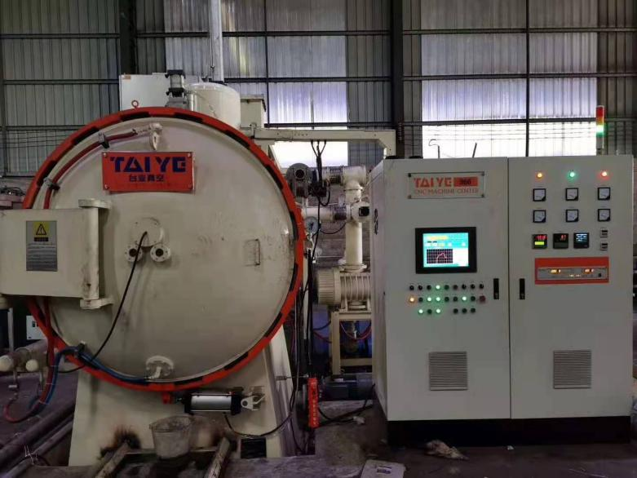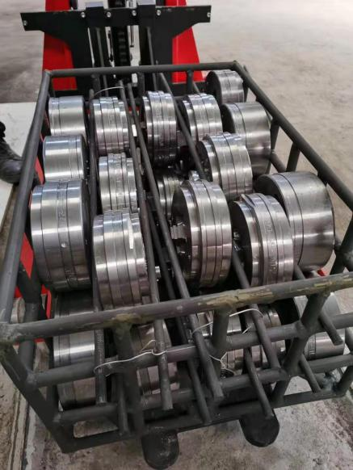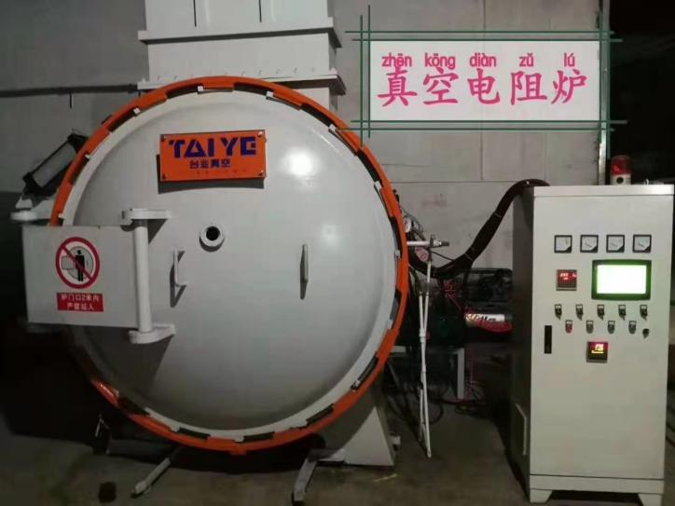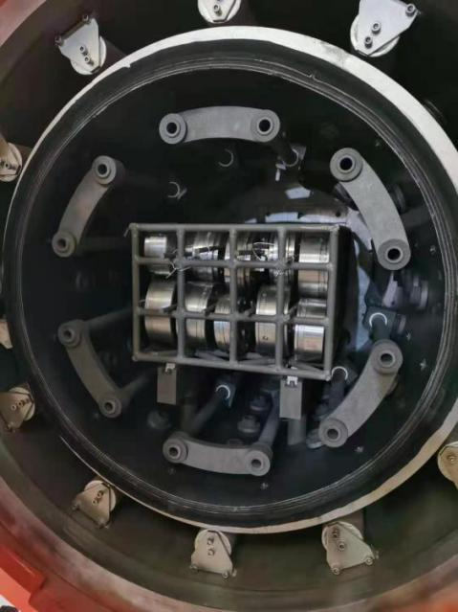
Vacuum heat treatment is a comprehensive technology combining vacuum technology and heat treatment. It means that all and part of the heat treatment process is performed under vacuum. The vacuum heat treatment furnace has high thermal efficiency, can realize rapid heating and cooling, can realize no oxidation, no decarburization, no carburization, can remove phosphorus chips on the surface of the workpiece, and has the functions of degreasing and degassing, so as to achieve the effect of surface bright purification.

7. Hole EDM Drilling Machine
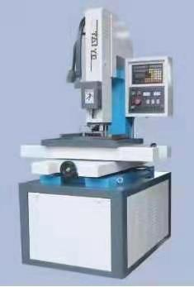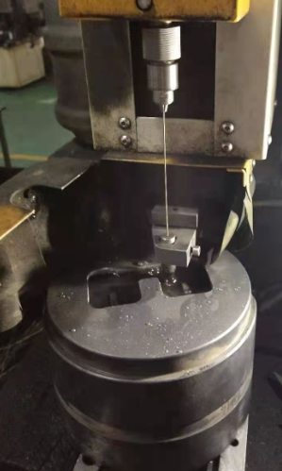
EDM perforator, also known as EDM perforator, EDM keyhole machine, EDM fine hole discharge motor, its working principle is the use of continuous up and down vertical movement of fine metal copper tube (called electrode wire) as the electrode, on the workpiece pulse spark discharge etching metal forming.
Different from the EDM wire cutting machine and forming machine, the electrode of its electric pulse is a hollow copper bar, and the medium passes through the fine hole in the middle of the copper bar hole, playing the role of cooling and chip discharge. The discharge between the electrode and the metal produces high temperature corrosion of the metal to achieve the purpose of perforation. It is used for processing the die after heat treatment. The wall thickness of the aluminum profile is relatively small, and the diameter is too small to be suitable for the die of wire cutting through the wire hole drilled by the drill bit.

8.Speed EDM wire Cut (Medium Speed) 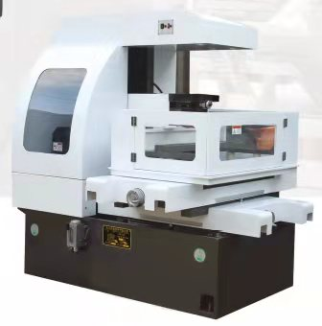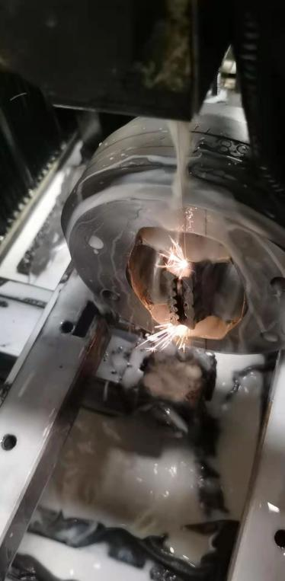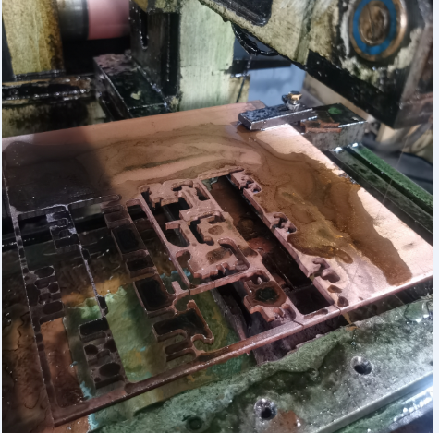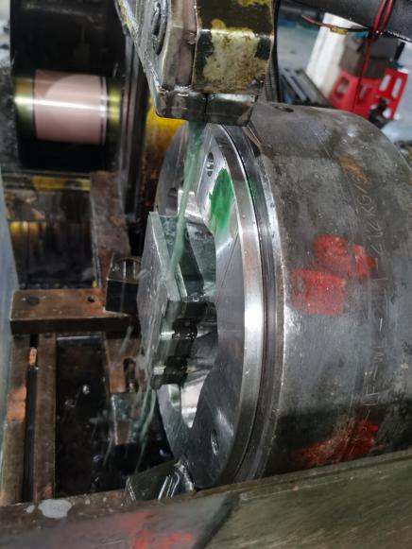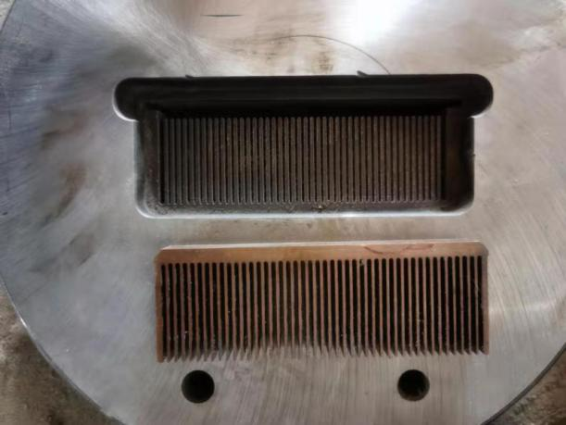
Speed EDM wire Cut is an original electric discharge wire cutting (EDM) made in China. Molybdenum wire is generally used for fast - moving electrode wire. Can be engaged in high speed and high precision processing, simple and convenient operation, overall high cost performance. In addition, it is very important that the processing speed of fast silk is fast, that is, the processing efficiency will be relatively high, and the production cost is relatively low. It is suitable for cutting copper plate for processing the relief of the solid dies of the split die and cutting the Hollow dies of the mandrel core of the upper die and the working belt of the die which is not too high on the surface of some aluminum profiles. such as High density tooth radiator.
The appearance adopts the sheet metal completely surrounded design, to ensure the factory environment clean and tidy.

9.Speed EDM wire Cut
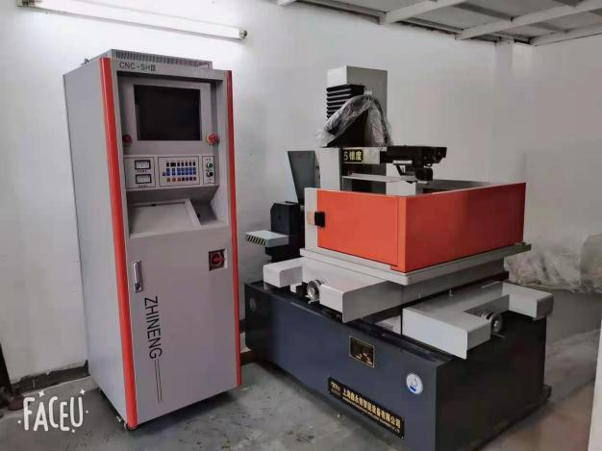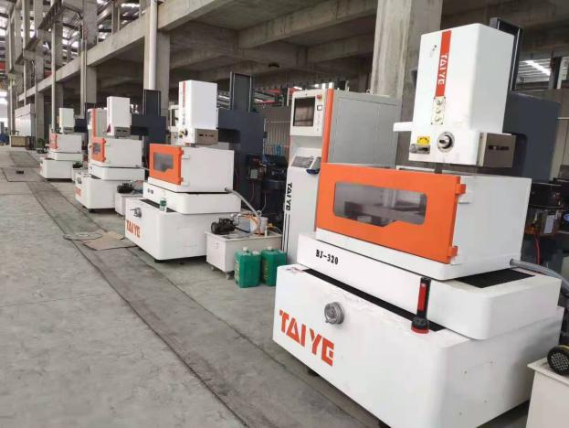
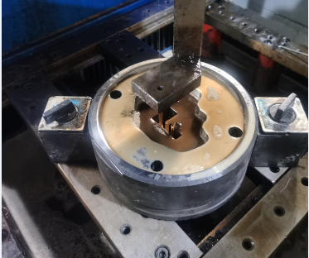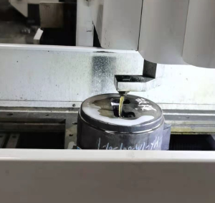
Correspondingly, the machining accuracy of fast speed wire moving machine is not as good as that of medium speed wire moving machine. The surface roughness of fast moving wire products is also poor. Medium speed wire cut is developed from fast speed wire cut, so its basic processing principle is the same as fast speed wire cut. On the basis of retaining the characteristics of simple cutting structure, low cost, good technological effect and less consumption in the process of using fast speed wire cut , the disadvantages of poor processing quality of the original fast speed wire cut have been greatly improved. The surface roughness of the medium-wire product can reach R0.8.
In China, the market share of medium speed wire cutting is the highest.

10.Slow brass EDM wire cut
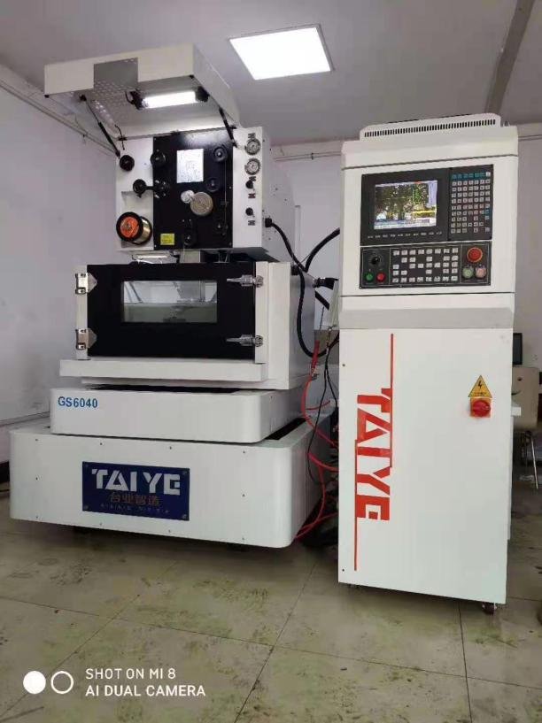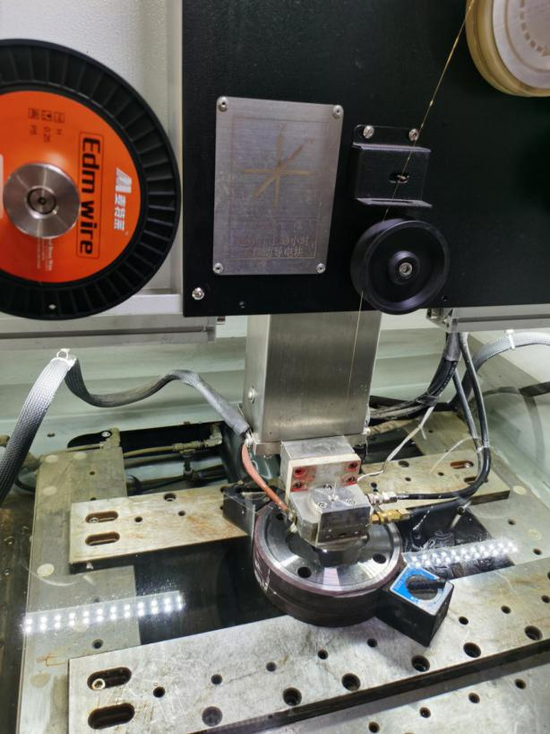
Slow wire cutting is the use of brass, copper, copper as the main alloy or coated material electrode wire, slow wire cutting is a necessary tool for each aluminum mold factory. Taiye company's slow wire cutting machine is specifically for aluminum extrusion die independent research and development of a cost-effective, cutting surface finish is good and can meet the high quality of aluminum surface products,

- engraving and milling /Economical engraving and milling machine (for copper electrode milling) 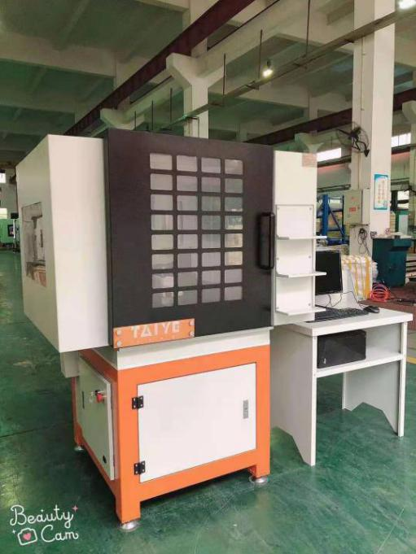
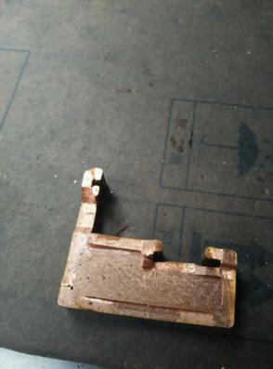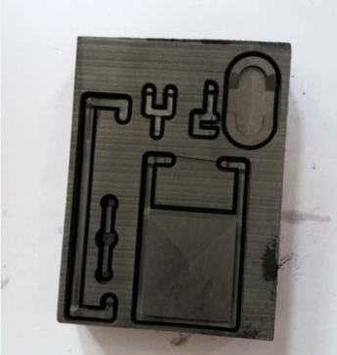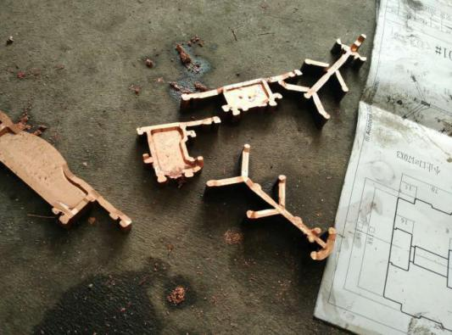
This economical engraving and milling machine is specially designed by our company for aluminum extrusion molds(for copper electrode milling). It is cost-effective. It is equipped with non-programming intelligent software developed and created by our company. It does not require programming or professional skills. Our equipment Easy to operate, with a complete graphical interface.
The products produced by our machines are accurate in size and beautiful in appearance, at the same time, it will greatly improve production efficiency,
you will no longer worry about quality, efficiency and workers
Taiye Machinery, intelligent manufacturing for you.

12.Sinker EDM Machine
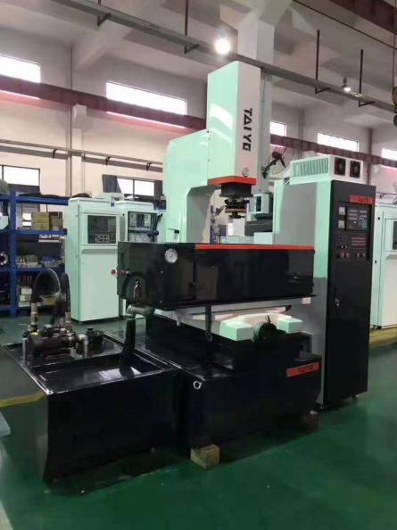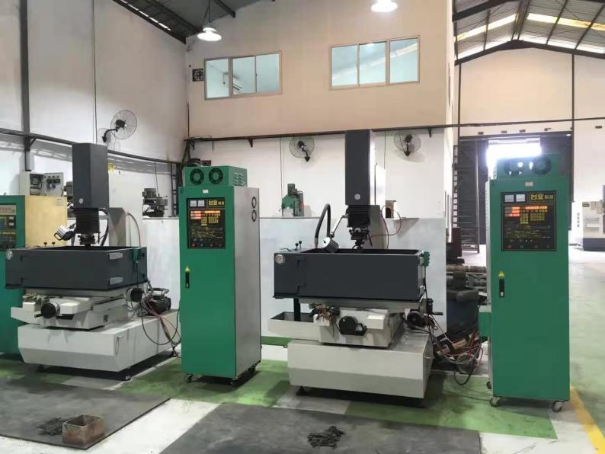
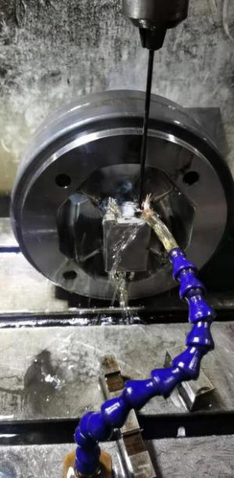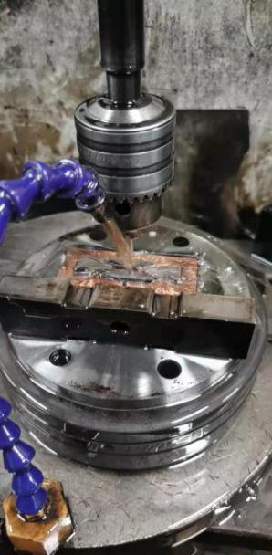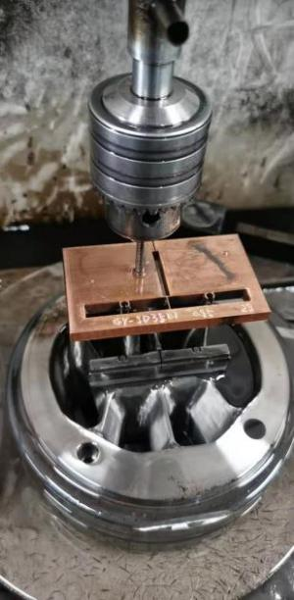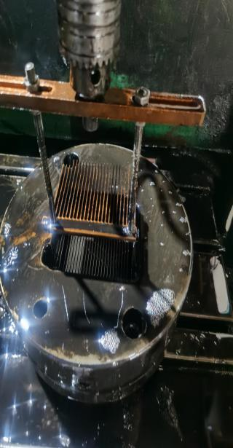
Sinker EDM (Sinker EDM) refers to a method of processing a workpiece in a certain medium through the electric erosion effect of the pulse discharge between the tool electrode and the workpiece electrode.
In the process of making aluminum extrusion dies, the EDM machine is used for a wide range of purposes. The space for a high-power radiator is too small, and the tools of the CNC machine cannot be processed. We choose copper electrodes to process on the EDM machine to ensure The copper electrode loss is small while increasing the strength of the dies.

13.Manual surface grinding machine
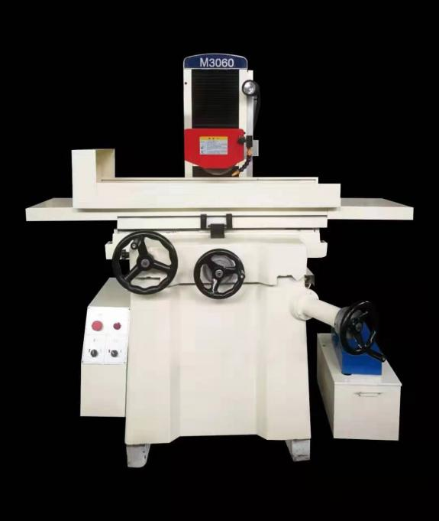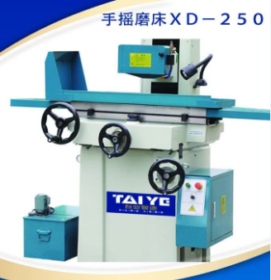
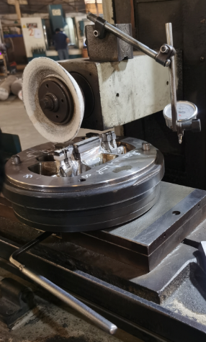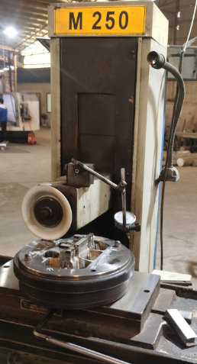

High Cost-effective
High plane machining accuracy and good retention
Stable structure design, good vibration resistance, to ensure the verticality of the convex mold Die bearing after processing, improve mold quality and accuracy.

14.Surface grinding machine/Surface grinding machine Round Table
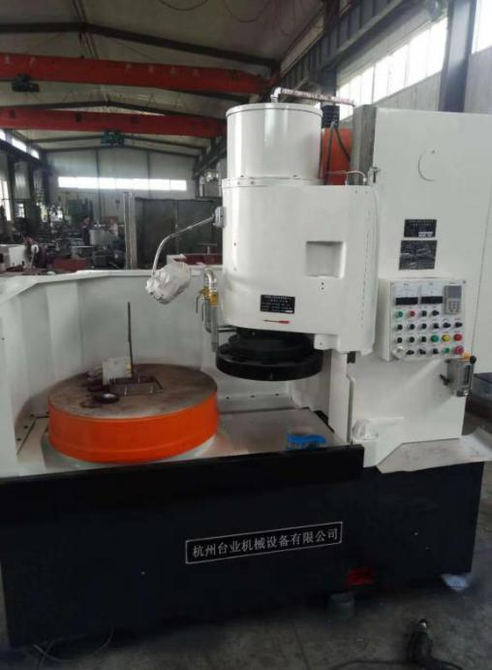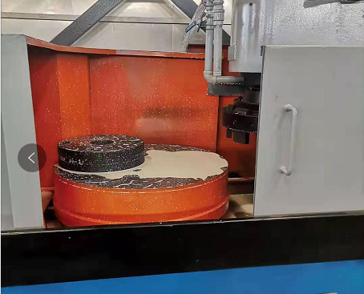
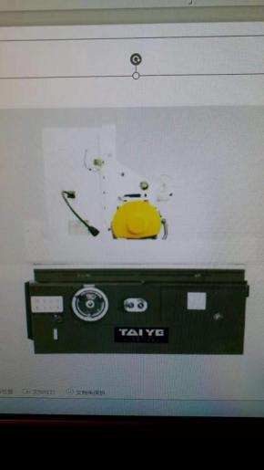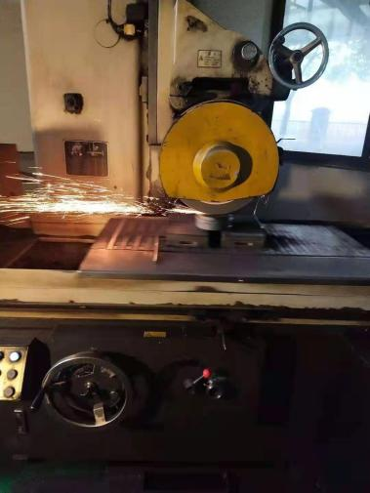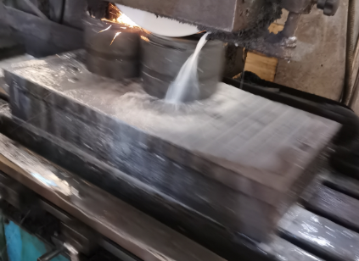
- The bed and grinding head have strong rigidity.
2, the column adopts three-point adjustment, compact structure.
3. The worktable is a circular powerful electromagnetic chuck.
4. High power, can charge and demagnetize empty silicon.
5. Equipped with coolant purification device.
The machine has the characteristics of large machine power, high grinding efficiency, simple and convenient operation.

15.Turret Milling Machine
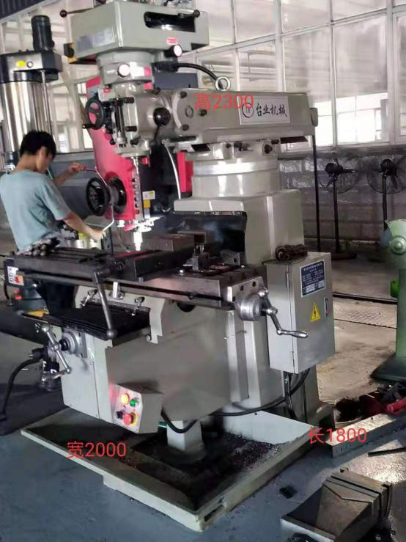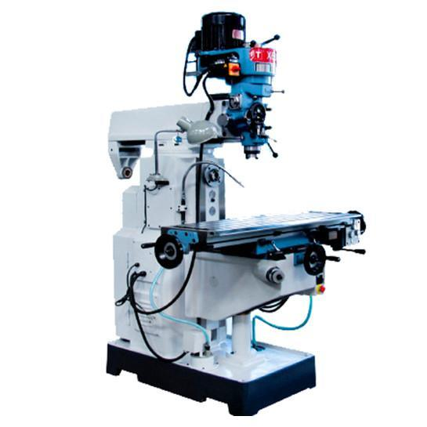

The vertical turret milling machine can be widely used for processing planes, bevels at any angle, milling keyways, grooves, and can also rotate, ream and drill. The milling head can rotate 90 degrees left and right, and 45 degrees front and back. Pan 360 degrees. The spindle speed range is wide and the verticality is high. The spindle sleeve can move and feed at a fixed distance, and is equipped with an overload protection device. The main shaft sleeve, machine tool guide rail and worktable are all high-frequency quenched, which is beautiful and practical.
The arbitrarily rotating spindle head is more convenient to handle the places that cannot be processed by the CNC milling machine, such as the bridge position of the extrusion die, the connection between the punch and the end surface, etc.

16.Environmental polishing platform
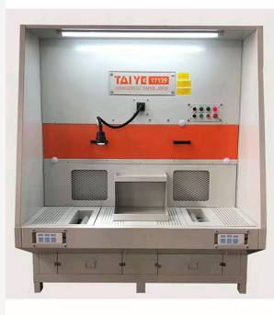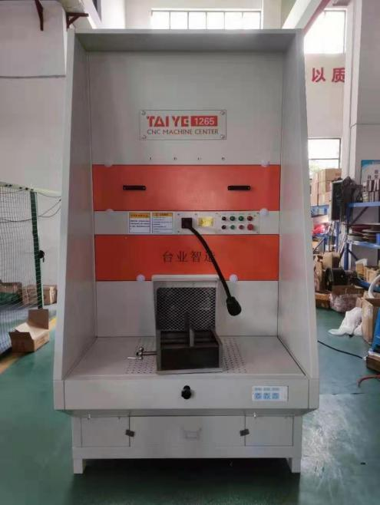
This new type of Environmental polishing platform is designed by our company for post-processing, grinding and correcting of extrusion molds. The fan inside the machine has a large power, which effectively collects the grinding dust into the machine to facilitate waste disposal and effective protection. The on-site environment has also greatly improved the working environment of the operators

17.Polishing/correction die platform
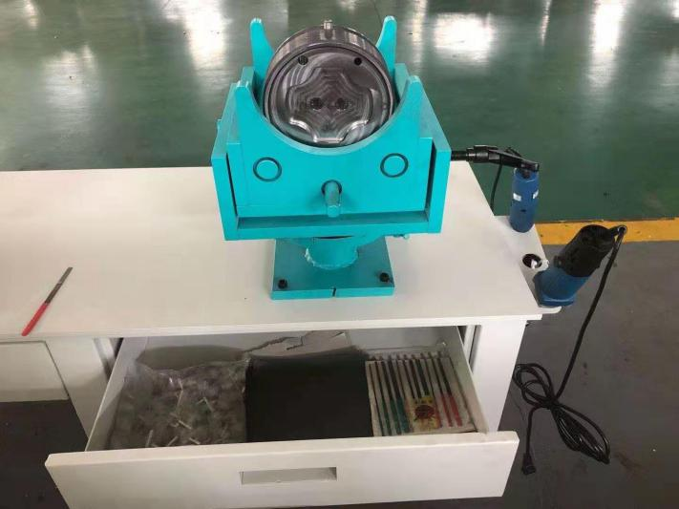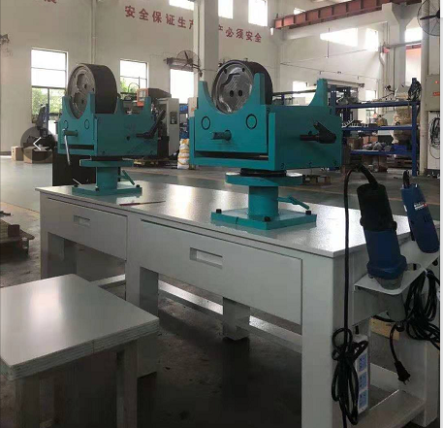
This polishing/repairing mold platform is specially designed for polishing and correcting molds after line cutting of extrusion molds. Not only is it easy to operate, especially the worktable can be rotated 360 degrees. For large molds, manual turn is no longer required, saving labor and time, and improving efficiency.

18.Pit Vacuum Pulse Nitriding tempering Furnace
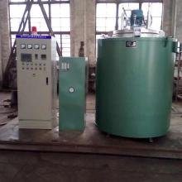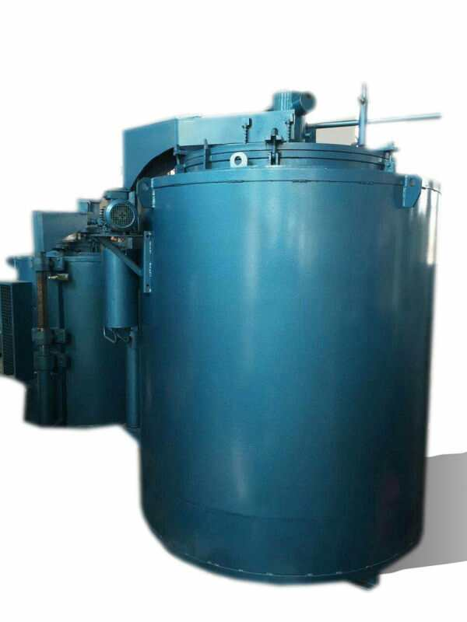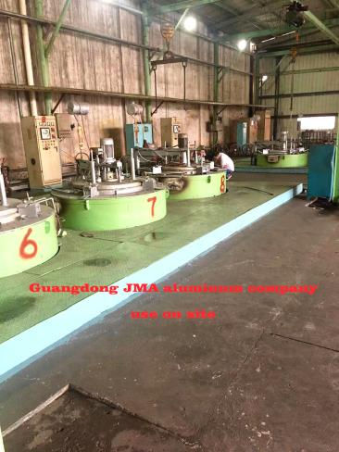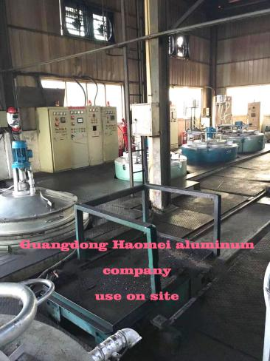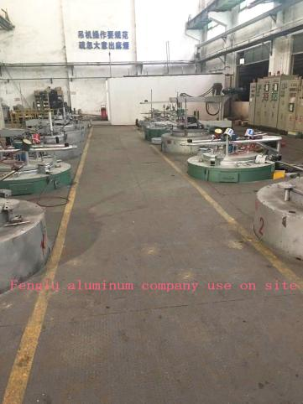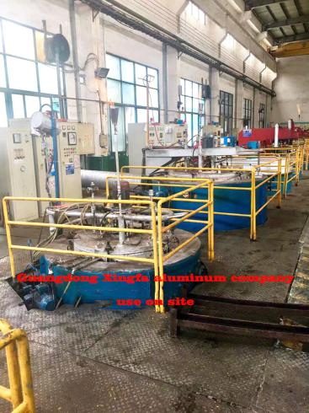

The tempering furnace is used for the tempering of general metal parts in the air and the quenching, annealing and aging heat treatment of light alloy parts such as aluminum alloy die-casting parts, pistons, and aluminum plates. After nitriding treatment, the die bearing is more wear-resistant and longer service life for the mold dies.
Taiye Nitriding tempering Furnace, The structure of the furnace is reasonable, the furnace temperature is uniform, has better heat insulation performance and saves energy.

